GREN RIVER, UTAH CANOE TRIP - Labyrinth Canyon 5/24/04
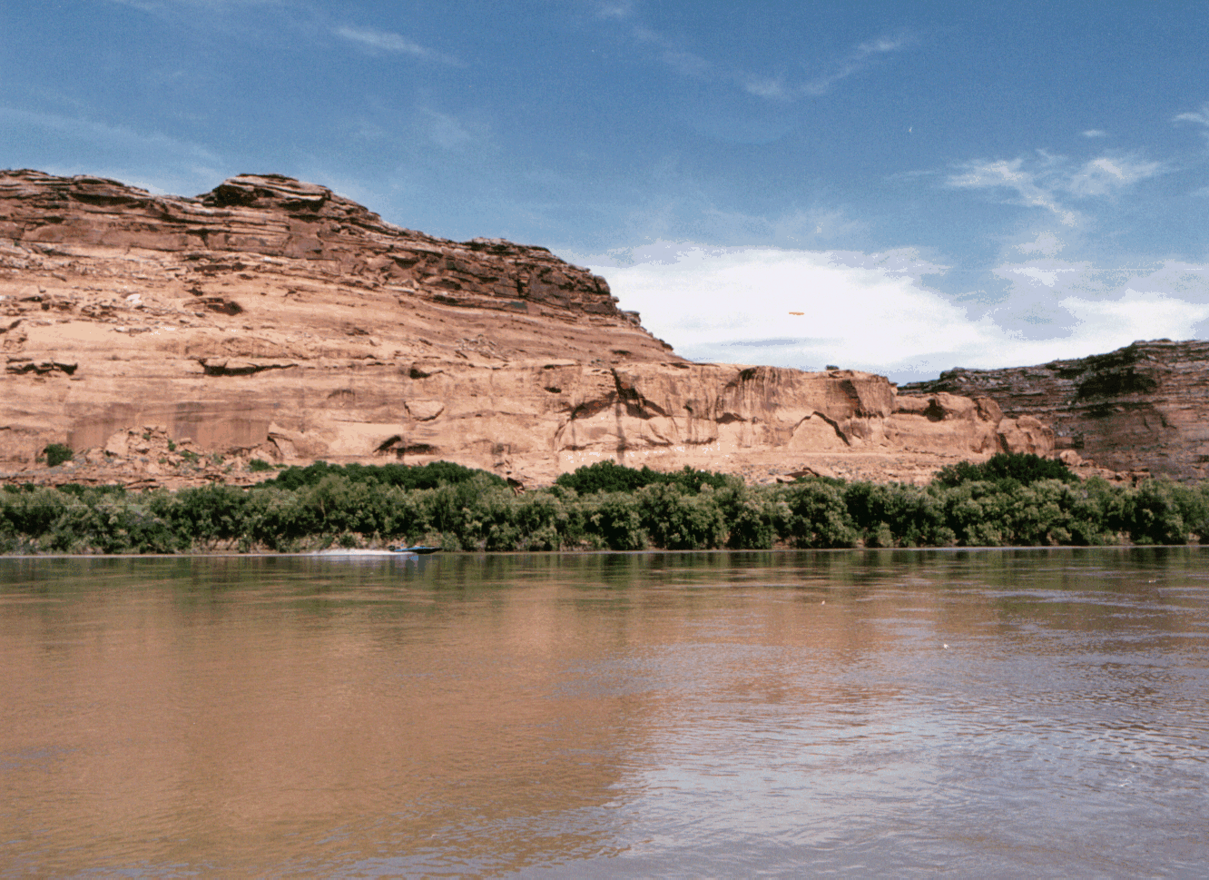
River recreation in Labyrinth Canyon is jointly managed by the U.S. Bureau of Land Management and the Utah State Division of Lands and Forestry. These agencies have adopted one set of regulations for river recreation and have joint enforcement responsibility. The Price BLM office is the official public contact point for Labyrinth Canyon information and permits.

Permits are required for all boating trips in Labyrinth Canyon. Permits are available free of charge from any of the following: BLM in Price or Moab, Canyonlands National Park Headquarters, Green River State Park, John Wesley Powell River History Museum, Moab Information Center and the Moab Office of Utah Division of Lands and Forestry. The following private companies are also authorized permit outlets. In Moab, Canyon Voyages Tag-A-Long Tours and Tex’s River Expeditions. In Green River, Holiday River Expeditions, Moki Mac River Expeditions and Ruby Ranch. The approved permit must be in the trip leaders possession while in Labyrinth Canyon and all permit stipulations must be followed.

A trip through Labyrinth Canyon on the lower Green River can be enjoyed almost any time of the year, except in winter when there is ice on the river. It is an easy, flat-water stretch suitable for canoes, kayaks, and rafts of all types. The heaviest use is between Easter and Labor Day. This portion of the river is also used by motorized craft. The Annual Friendship Cruise, a motorboat event takes place on Memorial Day Weekend. Be aware that during low water, motor boats are limited to a narrow channel, which you are sharing with them.

The river level fluctuates throughout the summer. Peak runoff from mountain snow melt generally occurs from the end of May to mid-June. Then the water flow gradually decreases to its low point in the fall and winter. July and August are the hottest months, and afternoon thunderstorms are common during this period. A minimum of three to four days should be allowed for the 68 river miles from Green River to Mineral Bottom. More time will be required to explore the many sites along the way.

The area is remote and services are non-existent. Your group must be self-contained and self- reliant to deal with emergency situations. Cellular phone service is not available within the canyons. Plan to carry all your drinking water. The Green River is very silty and quickly plugs up a water filter.. At some water levels, the river is too salty for drinking, even if you are successful at filtering it.

Much of the land between the city of Green River and Ruby Ranch, 23 miles downstream, is privately owned. Below that point, most of the land is state or federally managed. There are only a few restrictions on camping. Proper back country etiquette--cleanliness, hauling out of all waste, and respect for property rights--will help maintain this situation. Utah State boating and fishing regulations apply.

The most common put-in point for the trip is at Green River State Park. The usual take-out is at Mineral Bottom, where a ranger is on duty most of the time from mid-March through October. Access to Mineral Bottom is via State Highway 313 north of Moab. The turnoff to Mineral Bottom is marked by a small sign, prior to Dead Horse Point State Park-Canyonlands National Park junction. The 17 miles of dirt road to the take-out are usually in good condition, but can be very slick and even impassible when wet. This road is best suited to vehicles with high ground clearance.

Travel beyond Mineral Bottom is possible, but more planning is required. Fifty-two additional miles of flat water in Stillwater Canyon wind through Canyonlands National Park to the confluence of the Green and Colorado Rivers. The National Park Service requires that you obtain a back country permit when boating in the park. Contact them at Canyonlands National Park, 2282 South Resource Road, Moab, Utah 84532, (435) 259-4351. Down stream of Spanish Bottom are the white water rapids of Cataract Canyon, access is strictly controlled by the National Park Service.
There is no vehicle access take-outs below Mineral Bottom. You must transported via jet boat from the confluence back up the Colorado River to Moab. Contact either of the following: Moab/Green River Visitor's Center at (801) 259-8825 / 1-(800)-635-MOAB or the Green River Visitor Center at (801) 564-3526 for names of businesses which can provide vehicle shuttles or pick up. Some outfitters also rent boats and other equipment.

Canyonlands River Guide by Bill and Buzz Belknap, covers the Colorado River from above Westwater Canyon through Cataract Canyon to Lake Powell and the Green River from Green River, Utah to its confluence with the Colorado River This book is available from the Canyonlands Natural History Association at (800) 840-8978 or at the Moab Multi-agency Visitor Information Center at Main and Center in Moab, UT 84532. You may also want to ask for a complete catalog of the books and maps available.

The following provides additional information, all of it germane to having a successful trip. Pay particular attention to the Special Rules for Labyrinth Canyon and the Utah State Boating Act information. There is also information on emergency evacuation, toilet systems and some tips for low impact camping. By following these guidelines, you will have a safe and pleasant trip. You will also be leaving the canyon in good condition for those that follow. If we can be of further assistance, do not hesitate to contact this office at (435) 636-3622.
Shuttle Services:
Shuttle charge $250.00 for four people and gear. For each additional
person over four it is $25/person. There is a 6.6% Utah tax.
Trent and Kaycee Fluckey
Green River, Utah 435-564-3246
Green River Shuttle Service
Green River, Utah 435-564-8292
Red River Canoe Company
435-259-7722
Mary's Shuttle Service
Green River, Utah 84525
435-564-8381
River Runners Shuttle Service
Green River, Utah 84525
800-241-2591, 435-259-3512, 435-260-2019 www.desertsw.com
Tag-A-Long
800-453-3292(jet boat)
Tex's River Ways
435-259-5101 (jet boat)
Lake Powell Air Service
435-259-7421
Slickrock Air Guides
435-259-6216
EMERGENCY EVACUATION PROCEDURES LABYRINTH CANYON OF THE GREEN RIVER.
Should a member of your party have an injury which requires medical attention, three means of transportation are available as follows:
- When time is not a factor and the injury would not be further compounded by river travel, evacuation by raft is usually the best. Above Trin Alcove Bend, Green River State Park, Crystal Geyser and Ruby Ranch are the most likely places to access help. Below Trin Alcove, plan to continue on to Mineral Bottom.
- When time becomes a factor with increasing severity of the injury, vehicles or telephones can be reached at the following locations at or near the river:
- The river can be reached by vehicles at Green River State Park (river mile 120), at the cable crossing (river mile 1182), Crystal Geyser (river mile 1152), Little Valley (river miles 115 through 1102), McCarty Bottom (river mile 108), Ruby Ranch (river mile 96). The few vehicle access points between Ruby Ranch and Mineral Bottom are seldom used jeep trails which may be impassible.
- Should the injury be very severe (life-or-death situation) and time is a definite factor, or when body movement during evacuation must be limited (i.e., severe head, neck, back or broken femur (thigh injury), a helicopter should be considered. In most cases, the injured party will be billed for helicopter evacuation. When possible, a large, flat area should be chosen for the helicopter to land. The area should be marked with bright colored material forming a cross to help spot your location from the air.
TELEPHONE NUMBERS FOR EMERGENCY ASSISTANCE ARE:
Remember to call 911 or the local sheriff's department first. They are equipped to handle emergencies quickly and efficiently. They know the area best.
Utah Department of Public Safety, Price, Utah @ 911 or (435)637-0893 or (801)637-1621.
Emery County Sheriff, Green River, Utah (435)564-9669; Castle Dale, Utah (435)748-2404; or dial "O".
Grand County Sheriff, Moab, Utah (435)259-5612; or dial "O".
Air Life, Saint Mary's Hospital,
Grand Junction, Colorado; 24-hour toll-free
Number 1-800-525-4224.
Flight for Life, University of Utah Medical Center, Salt Lake City, Utah; 24-hour toll-free
number 1-800-662-0050.
Bureau of Land Management, Moab, Utah (435)259-6111.
Bureau of Land Management, Price, Utah (435)636-3600.
RIVER USE REGULATIONS FOR
LABYRINTH CANYON OF THE GREEN RIVER
Private and Noncommercial Users
General Requirements
Trips may be delayed or terminated if regulations are violated. Failure to comply may also result in criminal and/or civil penalties under Federal or Utah law. Permits are required for all river trips in Labyrinth Canyon.
1. The permittee must allow rangers to inspect the permit and required equipment and to orient the participants about river safety and etiquette. Upon request, the permittee must present the non- transferable permit along with a photo ID.
2. The permit must list any sponsor, affiliated organization, e.g., scout troop, school, etc. associated with the trip.
3. The trip must be noncommercial. No person or organization may make money or increase their net worth as a result of this trip. No fees may be collected in excess of actual trip expenses.
4. The permittee must have at all times in canyon:
a. A group of people not to exceed 25,
b. A washable, leak-proof, reusable toilet system that allows for the carry-out and disposal of human feces via an authorized sewer system. The toilet(s) must be of adequate size for the group size and trip length,
c. A durable metal fire pan at least 12 inches wide
with at least a 1.5 inch lip around the outer edge and sufficient to contain fire and remains. Fire pans must be carried on all overnight trips.

Boating Safety
1. There shall be a proper size, serviceable, Type I, II, III or V PFD readily available for each person, on each vessel. Persons under age 13 must wear their PFD at all times on the water.
2. Each vessel shall have a spare means of propulsion. Low capacity vessels under 16 feet in length (kayaks, canoes, inflatable kayaks) carry spare paddles as follows: 1-3 vessels require 1 spare paddle, 4-6 vessels require 2 spare paddles, 7 to 9 vessels require 3 spare paddles, etc.
3. A bailing bucket or bilge pump (does not apply to self bailing boats, kayaks with spray skirts and inflatable kayaks).
4. Each boat 16 feet long or longer must have immediately available, a Type IV throwable PFD or a commercially made river throw bag with a minimum of 40 feet of line
5. Adhere to the Utah Boating Act (Title 73, Chapter 18) including registration of motorized boats, required equipment, and operational requirements.
Conservation of Natural Resources
1. The permittee must ensure that all trip participants:
a. Carry out all charcoal, fire ash, garbage, trash, human and pet feces out of the canyon. Leaving human or pet feces in the canyon or dumping it into restrooms or trash receptacles at public facilities is prohibited. Gray water, strained free of solids, and urine should be discharged into the main stream of the river.
b. Not remove, damage or destroy archaeological, historical or ecological resources or mark or deface any rock surface, trees or other vegetation.
c. Launch, travel (stay in visual contact), and camp together as a group. Groups launching separately may not camp together if such action would result in more than 25 persons occupying a camp.
e. Limit firewood gathering to river drift wood only and fully contained fires in the fire pan.
A Few Tips on Leave No Trace Camping in Labyrinth Canyon.
Fires and Saunas: Consider whether you really need a fire; it's OK to camp without one and enjoy the night sky. If you need a fire, use a fire pan to eliminate any trace of your campfire. Fire rings, blackened rock and charcoal advertise your fire to future users. Elevate the fire pan, pick up any charcoal that falls out. Consider using a welder's blanket to catch debris. Pack out all ash and charcoal., If you have a sauna, consider using "permanent" sauna rocks you pack with you. This also avoids the risk of exploding rocks. If you must use native rock (please, no oil shale) heat the rock on a stove or on a grill after your fire has burned down to coals. Toss the rocks into the main current of the river after you are done with them.
Who invited ants to the picnic?! Most likely you did if you toss dish water or other water based, liquid waste anywhere but in the river. On desert, high volume rivers, this is a preferred and least impacting practice. Some of our camps are overrun with ants and the surface deposition of food scraps and dish water is a major reason. Use a tarp under the table to catch those crumbs, spills and drips. Strain the dishwater to remove food scraps and pack them out with your trash.
Firewood: Trees grow very slowly in this environment. However, we have a great renewable source of firewood in the canyon; it is called drift wood. Each year we receive a fresh supply from the Uintas and the mountains of the Colorado.
By using the imported rather than the domestic wood you preserve the character of the canyon and don't displace the critters who call dead trees home. Not sure if your next camp has an adequate supply of firewood? Stop at a handy, upstream driftwood pile and you can easily carry enough wood for an evening fire. Please don't break and hack away at our longtime canyon residents. And by the way, if you should gather to much firewood, don't forget to disperse the woodpile -Leave No Trace of your passing.
Toilets: River corridors are small, narrow and heavily used by both people and wildlife. Toilets are required to pack out solid human waste, pet waste and toilet paper. Cat holes are unacceptable. Even above the high water mark, animals will dig them up. Biologic activity in our desert soils in minimal. Toilet paper and feces take years to break down. There are only two good places to urinate in the canyon. One is in the river, the other is far away from any camp site or tent sites associated with a camp. The soil here are not very active, urine does not break down, It merely gets rancid and smells bad. Wonder what the odd odor was a your last tent site. Now you know. Consider setting up your toilet close to the river or providing a bucket with some water in it for urine. The bucket can then be dumped into the river. Remember. "Number one goes in the water because we oughter, Number two goes in the can 'cause that's our plan."
Deadman: Your bow line is too short so you buried a post (deadman) to tie up your boat. Don't forget to remove the post. The water may be low now, but when it rises, your deadman may rip a boat or injure a swimmer at higher water levels.
Major First Aid Kit for Extended River Trips
Backcountry trips take place within the wilderness context i.e. dialing 911 is not an option. Groups must be prepared to deal with emergencies and care for the sick and injured for an extended period, from several hours up to several days.
First Aid Kit contents should be commensurate with you level of skill and training in First Aid. Major First Aid Kits should contain items in the following groupings:
1. Rescuer personal protection equipment: | Latex gloves  Eye protection  Rescue breathing mask with one way valve.
2. Wound care and management: | Compresses and both gauze and compression bandages.  Soap, disinfectant and instruments to clean wounds.  Burn dressings and treatment.  Splinting materials.  Scissors/shears, tweezers, needles, scalpel or razor blade.
3. Dental kit with (Optional but highly recommended) | floss  wax  oil or clove
4. Medical | Pain relief medication.  Stomach ache and diarrhea medications.  Topical anti-rash preparations.  Drugs as prescribed for trip members. Pay close attention to people with allergies, asthma and cardiovascular conditions.  Allergy treatments.  Thermometer (hypo/hyper thermal)
5. Any other equipment or supplies you are competent to use, willing to carry and applicable to the environment.
If no one on your trip has the skills to utilize these items, you should reevaluate your decision to undertake a backcountry expedition.
Highlights of the Utah State Boating Act for Labyrinth Canyon Users
The following information is for non-commercial boating groups. If you are carrying passengers for hire or receiving compensation for conducting the trip or participating in a trip which is not a common adventure with all participants sharing equally in trip costs, other State and Federal requirements apply. Contact BLM at 435-636-3622.
Each vessel must have:
- For each person on a boat, a serviceable, properly fitted, personal flotation device (PFD, formerly known as a life jacket) with a U.S. Coast Guard Type rating of I, II, III, or V.
- The BLM recommends against the use of Type II PFD's on rivers. Persons of 12 years of age and younger must wear their PFD while on the boats. For persons over age 12, the PFD must be readily available.
- An extra means of propulsion i.e. a spare motor, oar or paddle. Parties using only low capacity vessels under 16 feet in length (kayaks, inflatable kayaks, canoes) must carry at least one spare paddle per three vessels. One to three vessels require one spare paddle, four to six vessels required two spare paddles, and so on.
- A bailing bucket or bilge pump. Does not apply to self bailing boats, kayaks and inflatable kayaks.
- Each vessel 16 feet long or longer must have immediately available, a type IV throw able device or a throw bag with at least 40 feet of line.
Motorized craft must be registered.
THINGS TO SEE ON THE GREEN RIVER THROUGH LABYRINTH CANYON FROM GREEN RIVER, UTAH TO MINERAL CANYON BOAT RAMP
PLEASE DO NOT DESTROY OR DEFACE HISTORICAL SITES
(East Side) CRYSTAL GEYSER was the result of an oil well being drilled. At one time it erupted every hour going 100 feet in the air. Although it is no longer as predicable maybe you'll be lucky enough to see it. About 2 mile below the geyser is the AUGER, a series of corkscrew bends in the river.
(West Side) McCARTHY BOTTOM. Back on the ledge can be found old Indian writings.
(East Side) ANVIL BOTTOM, so named for the anvil-shaped rock above the river. The marker is on the lower end of the bottom, and it also marks the upper end of DOC BISHOP BOTTOM, where there is an old cabin.
(East Side) Upper end of the RUBY RANCH, now owned by "Dunham Livestock." This marker also marks the site of an old TB Sanitarium. The remains of the old water wheel you see was put in by Glen Ruby, but it never pumped water because it was placed in an eddy. The San Rafael River joins the Green River on the opposite shore across from a boat ramp.
(East Side) The start of the canyon walls which you will be in for the rest of your journey down the Green River.
(West Side) THREE CANYONS, a spot where three box canyons all mouth at the same place. This is a very heavily used site, please consider an alternative campsite.
(East Side) TEN MILE CANYON. One must go 10 miles up the canyon before you can get on top.
(West Side) KEG SPRING CANYON - TRAIL OUT.
(East Side) REGISTER ROCK Names of river runners chiseled in ledge. Also some Indian markings. DO NOT ADD YOUR NAMES TO THE ROCK, USE THE REGISTER BOOKLET PROVIDED.

(East Side) D. JULIEN, MARCH. 1836. Early river explorer.
(West Side) BOW KNOT There is also a rock up in the notch bearing names of old boaters. They called it the POST OFFICE . Also from this point you can almost throw rocks into the river on both sides. It will be about seven miles around the bow.
DO NOT ADD YOUR NAMES TO THE ROCK, USE THE REGISTER BOOKLET PROVIDED.
Labyrinth Canyon Map
